NREGA Sangharsh Morcha: Pre-Budget Press Release

Government Reports show 15%-20% of the NREGA Budget generally spent on clearing pending liabilities of previous years

NREGA need 1 lakh crore to run smoothly

31st January’2020

Rural distress has risen to alarming levels. As per the Periodic Labour Force Survey (PLFS) of 2017-18, rural unemployment stands at 8 percent (statement 30 in Section 3.7, PLFS). In conjunction with skyrocketing food inflation levels, this is a serious concern. The situation is much worse for the landless depending on casual manual labour who constitute more than half the rural population. It is in this context that strengthening the National Rural Employment Guarantee Act (NREGA) can be a huge relief.

Funds Crunch

Notwithstanding the rural distress, implementing the NREGA is a legal obligation of the Central government. However, the demand-driven nature of the Act has been repeatedly stifled in letter and spirit. By severe rationing of funds, it has been made a supply driven programme. In February 2019, the NDA Government allocated Rs 60,000 cr for MGNREGA. Out of this Rs 9,330 cr were pending wage liabilities from previous years. Therefore, the FY 2019-20 with an allocation of around Rs 51,000 crore, which is now finished. As of 28th January 2020, 91% of wages due for payment, i.e., nearly Rs 2,800 crore, have not yet been paid by the Central Government. Half the states of the country (15 out of 31) have no finances to implement NREGA in February and March 2020. 8 out of the remaining 16 states will immediately slip into negative balance if they clear their current pending wages. Due to under-provisioning, states with positive net balance are holding on to the limited funds they have and not clearing the pending wages. For instance, Chhattisgarh indicates a net available balance of Rs 62 cr, but simultaneously also indicates pending wages of Rs 180 cr. If the Government of Chhattisgarh uses its available balance to clear all pending wages it will immediately run into a negative balance of nearly Rs 118 cr with two more months to go in this FY. Lack of funds has brought the programme to a grinding halt.

NREGA Sangharsh Morcha demands a minimal allocation of Rs 1 Lakh crores in the FY 20-21 budget for NREGA. The rationale is as follows:
- Considering Rs 248 per personday (PD), for a projected labour demand of 270 crore PD in FY2020-21, the estimated amount is 248*270 = Rs 66,960 crores.
- On average, 25% of the total expenditure has been for material costs. This translates to 0.25*66,960 = Rs 16,740 crores for material component.
- As per the Act, 75% of the material cost has to be borne by the Central government. Thus the material cost to the central government is 0.75*16,740 = Rs 12,555 crores.
- The total allocation for the Centre for wages + material = Rs 66,960 cr+Rs 12,555 cr = Rs 79,515 crores.
- On average, in the last five years, one-sixth of each year’s allocation have been pending wage liabilities. Assuming that pending wages would be the same proportion going in to FY 2020-21, the component of pending wage liabilities is 79,515/6 = Rs 13,252 crores.
- Thus wages component + material component + pending liabilities = Rs 66,960+Rs 12,555+13,252 = Rs 92,767 crores.
- Assuming a 10 percent inflation and indexation adjustment to this we get a minimal allocation required for FY 2020-21 just to maintain the standards of FY 2019-20 is Rs 92,767 crores + Rs 9276.7 crores = Rs 1,02,044 crores, i.e., about Rs 1 lakh 2 thousand and fifty crores.

This is a conservative estimate since the central government has been slashing the labour budget and calling it “approved labour budget”.
Delay in wage payments and compensation: While the Ministry of Rural Development (MoRD) claims to have made progress in timely wage payments, large delays in wage payments still plague the programme. A recent article by the then Secretary, MoRD says that 75% of payments are credited in 15 days, but Figure 1 shows that once funds started drying up in October, this number would have fallen significantly. Additionally, despite calculating delays made by the centre in depositing wages, the delay made by the centre is not added to calculate delay compensation. The centre must fix accountability on the agencies that cause the delay and ensure that workers are compensated for the full duration of the delay in crediting their wages to their bank account. This continues to be in violation of Supreme Court Orders.
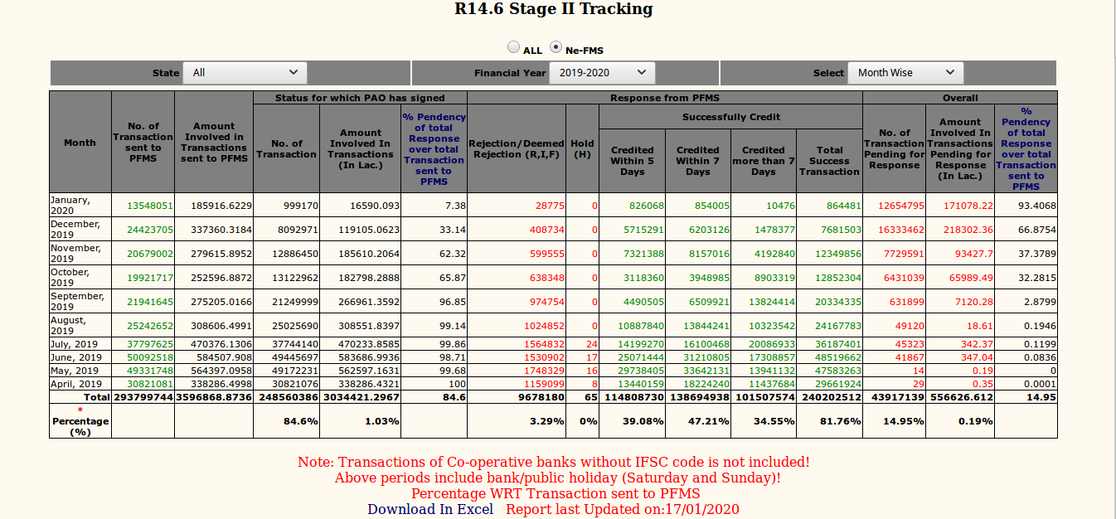

Stagnating wage rates: The issue of stagnating wage rates is not new to NREGA. The government's decision to index the wage rate to the Consumer Price Index - Rural (CPI-R) as opposed to the older Consumer Price Index - Agricultural Labourers (CPI-AL) is a welcome move. However, it is futile since the NREGA wages are very low to begin with. The new indexation will be meaningful if the NREGA wages are at par with the minimum wages in the states.

Strengthening gram panchayat planning: The Act had envisioned that Gram Panchayats would be instrumental in planning what work can be undertaken and what kind of assets can be built based on local needs. With the passing of years, the planning of what work should be undertaken is thrust by the centre. There is a need to ensure that the planning process is bottom-up in nature and gram panchayats have a greater say in deciding the nature of assets.

Annexure

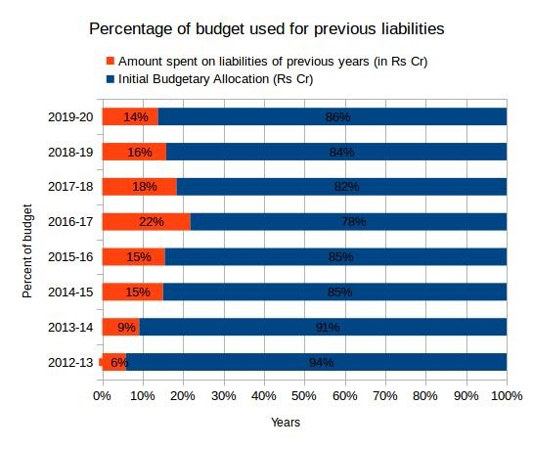
States with substantial pending wages to be cleared by the Central Government

State | Amount of Pending Wages (in Rs Crore) | Percent of FTOs not cleared
Chhattisgarh | 180 | 72
Jharkhand | 65 | 98
Karnataka | 139 | 100
Kerala | 157 | 97
Madhya Pradesh | 250 | 98
Odisha | 177 | 99
Rajasthan | 298 | 99
Uttar Pradesh | 400 | 100
West Bengal | 726 | 99

For further information, please write atnrega.sangharsh.morcha@gmail.com or contact Abhay Kumar (9845371493), AnuradhaTalwar (9433002064), Arundhati Dhuru (9919664444), GangaramPaikra (9977462084), Kamayani Swami (9771950248), MukeshNirvasat (9468862200), Neeta Hardikar (9825412387), Nirmala Tammineni (9848930031) orRicha Singh (9452232663) on behalf of NREGA Sangharsh Morcha.

